./

GENESIS - Learning Outcome & Mini-project Summary Report



|  |  |  |  |  |  |
| --- | --- | --- | --- | --- | --- |
| **Ver. Rel. No.** | **Release Date** | **Prepared. By** | **Reviewed By** | **To be Approved** | **Remarks/Revision Details** |
| 1.0 | 13/11/2020 | Minand Nellipunath Manomohanan |  |  | Final Draft |
|  |  |  |  |  |  |
|  |  |  |  |  |  |
|  |  |  |  |  |  |
|  |  |  |  |  |  |

**Details**

Contents

Contents2

Miniproject -1 [Team/Individual]4

Modules4

Topic and Subtopics4

Objectives & Requirements4

Design5

Test Plan6

Implementation Summary8

Video Summary8

Git Link8

Git Dashboard8

Individual Contribution & Highlights9

Summary10

Challenges faced and how were they overcome10

Future Scope (If applicable)10

# List of Tables

Table 1:High Level requirements 4

Table 2: Low Level Requirements 4

Table 3:Test Plan 6

Table 4: Unit Test Plan 7

# List of Figures

Figure 1:Sequence Diagram 5

Figure 2:Component Diagram 6

Figure 3: Git Dashboard 8

Figure 4:Build screenshot 9

Figure 5:Codacy Screenshot 9

# Miniproject -1 [Team/Individual]

A medicine dispensing system which will alert the patient to take the medicine on prescribed time.

The system will match the prescribed time with real time and alert the patient to take the medicine by turning on the LED. When the patient reaches for the medicine, the sensor detects the presence and dispenses the correct medicine. The name of the medicine will be displayed on the console of STM32.

## Modules

Linux Concepts

Embedded Linux (Beagle Bone Black)

Embedded C (STM32)

### Topic and Subtopics

* Linux Concepts
  + File Systems
  + Multifile Programming
  + Makefile
* Embedded Linux
  + Interfacing peripherals on Beaglebone Black(BBB).
  + Reading and writing from/to GPIO ports.
  + SPI protocol implementation on BBB.
  + Compiling and executing program on BBB.
* Embedded C
  + SPI communication with BBB.

## Objectives & Requirements

HIGH LEVEL REQUIREMENTS

Table 1:High Level requirements

|  |  |
| --- | --- |
| **ID** | **Description** |
| HL_01 | System will check the prescribed time with real time and alert the patient to take the medicine |
| HL_02 | Sensor in device should detect a hand to dispense the medicine |
| HL_03 | Green LED will indicate the dispensing of the medicine |
| HL_04 | The name of the medicine will be displayed on the console of STM32 |

LOW LEVEL REQUIREMENTS

Table 2: Low Level Requirements

|  |  |
| --- | --- |
| **ID** | **Description** |
| HL_01_L1 | Importing the .csv file |
| HL_01_L2 | Matching the real time data with the .csv file containing the prescribed timings |
| HL_01_L1 | Optimizing sensor range and time delay |
| HL_03_L1 | Alerting the patient for matched data |
| HL_04_L1 | Obtaining the medicine number from .csv |
| HL_04_L2 | Communicating with the STM32 |
| HL_04_L3 | Displaying received data on the console of STM32 |

## Design

Behavioral – Sequence diagram

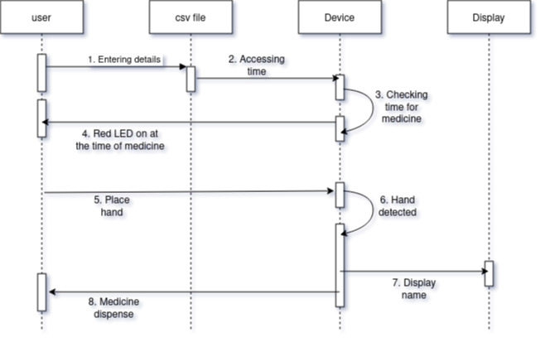

Figure 1:Sequence Diagram

Structural

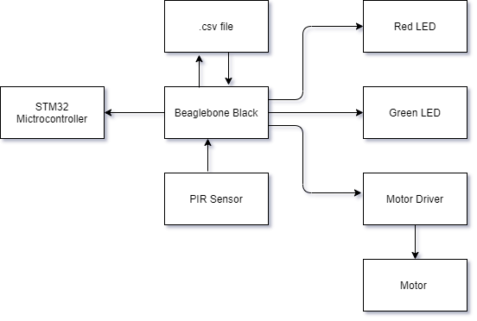

Figure 2:Component Diagram

## Test Plan

Integration Testing

Table 3:Test Plan

|  |  |  |  |  |  |
| --- | --- | --- | --- | --- | --- |
| **ID** | **Description** | **Pre-Condition** | **Expected Input** | **Expected Output** | **Actual Output** |
| HL_01_T1 | Checking the system at different time | Not yet Time to take medicine | Prescribed time to take medicine | No medicine number out | No medicine number is out |
| HL_01_T2 | Checking the system at different time | Time to take the medicine | Prescribed time to take medicine | Prescribed medicine number out | Prescribed medicine number out |
| HL_01_T1 | Checking the hand detection by sensor | Not yet time to take the medicine | Motion | No sensor value should be detected | No sensor value detected |
| HL_01_T2 | Checking the hand detection by sensor | Time to take the medicine | Motion | Sensor value must be high | Sensor value is high |
| HL_03_T1 | Checking for alert mechanism | Prescribed time to take medicine | Prescribed medicine number out | Led glowing to indicate the dispensing of medicine | Led glowing to indicate the dispensing of medicine |
| HL_03_T2 | Checking for alert mechanism | Not the Prescribed time to take medicine | No medicine number out | Led will not glow | Led will not glow |
| HL_04_T1 | Checking the display | Not time to take the medicine | No medicine number is out | Nothing is displayed on console | Nothing is displayed on console |
| HL_04_T2 | Checking the display | Time to take the medicine | Prescribed medicine Number is out | Medicine name is displayed on the console | Medicine name is displayed on the console |

Unit Testing

Table 4: Unit Test Plan

|  |  |  |  |  |  |
| --- | --- | --- | --- | --- | --- |
| **ID** | **Description** | **Pre-Condition** | **Expected Input** | **Expected Output** | **Actual Output** |
| HL_01_L1_U1 | Checking for successful import of .csv file | System is in Idle state | The .csv file with time and medicine number | Message displaying successful import of data | Message displayed |
| HL_01_L2_U1 | Checking matched time | When actual time is not same as the prescribed time | The csv data of time and medicine number | Zero to indicate no match | Zero |
| HL_01_L2_U2 | Checking matched time | When actual time is same as the prescribed time | The csv data of time and medicine number | Greater than zero to indicate the match | One |
| HL_03_L1_U1 | Checking the functionality of LED | When actual time is same as the prescribed time | When the value returned is greater than 0 | Led will glow | LED is On |
| HL_03_L1_U2 | Checking the functionality of LED | When actual time is not same as the prescribed time | When the value returned is zero | Led will not glow | LED is Off |
| HL_04_L1_U1 | Check to get the medicine number | When it is time to take the medicine | The .csv file | Medicine number is out | Medicine number |
| HL_04_L2_U1 | Checking the communication established between STM32 and BBB | When it is time to take the medicine | Medicine number | Message to display successful communication | Message displayed |
| HL_04_L3_U1 | Checking for printing the medicine name | When it is time to take the medicine | Medicine number | Medicine name based on the number | Medicine name |
| HL_04_L3_U2 | Checking for printing the medicine name | When it is not time to take the medicine | No medicine number out | Nothing is displayed | NULL |

## Implementation Summary

Medicine Dispenser is a project which is designed to check the time at which the medicine shall be taken by the patient. It alerts the patient at the right time and dispenses it.

Here the medicine number and the time to take it is entered into a .csv file by the patient. The device compares the time entered by the patient with the real time and turns on a Red Led to indicate that it’s time to take the medicine. Now the system waits for the detection of hand of the patient by the PIR sensor. Once the pir value is received, the red led turns off and the green led glows. At this time, the corresponding medicine number from .csv file is transferred via SPI protocol to STM32 Microcontroller. The controller then displays the name of the medicine. Also, the hand detection triggers the motor driver L298N to turn on the motor to indicate that the medicine is dispensed by the system.

### Summary

The system is designed to check the time to take the medicine by the patient and dispenses it at the correct time. Here the medicine number and the time to take it is entered into a .csv file by the patient. The device compares the time entered by the patient with the real time and turns on a red Led to indicate that it’s time to take the medicine. Now the system waits for the detection of hand by the PIR sensor. Once the pir value is received, the red led turns off and the green led glows. At this time, the corresponding medicine number from .csv file is transferred via SPI protocol to STM32 Microcontroller. The controller then displays the name of the medicine. Also, the motor turns to indicate that the medicine is dispensed by the system.

### Challenges faced and how were they overcome

We received segmentation fault while the code was dumped on the Beaglebone black. The debugging was done by adding printf statements in code so as to identify where the code was casing segmentation fault.

### Future Scope (If applicable)

* Instead of using the .csv file to give the input of the medicine number and the time to take the medicine we can have a web application to take input of the medicine and the time.
* Alert the patient by sending a text message to the patient to alert the patient to take the medicine.